About the XML_PassengerQuery message flow :
- If the input message provides only a reservation number, the message follows the SinglePassenger path and the output message contains information about only the flight with which the reservation number is associated.
- If the input message provides only a passenger's name, the message follows the AllReservations path and the output message contains information about all of the flights on which the passenger has reservations. This sample assumes that the passenger's full name is unique, which is not realistic but simplifies the sample.
Queues:
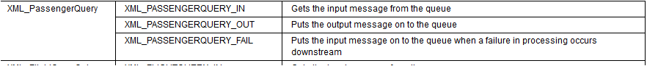
Input 1:

<PassengerQuery>
<ReservationNumber>CA937200305253</ReservationNumber>
<FirstName></FirstName>
<LastName></LastName>
</PassengerQuery>

Output 1

<PassengerInfoResponse>
<PassengerInfo>
<ReservationNumber>CA937200305253</ReservationNumber>
<FirstName>Debra</FirstName>
<LastName>Weiss</LastName>
<FlightNumber>CA937</FlightNumber>
<Date>20030525</Date>
<Class>Y</Class>
</PassengerInfo>
<PassengerInfoResponse>

Input 2:

<PassengerQuery>
<ReservationNumber></ReservationNumber>
<FirstName>Mary</FirstName>
<LastName>Smith</LastName>
</PassengerQuery>

Output 2:
<PassengerInfoResponse>
<ListOfReservations>
<Reservation>
<FlightNumber>CA937</FlightNumber>
<Date>20030525</Date>
<Class>F</Class>
</Reservation>
<Reservation>
<FlightNumber>BA039</FlightNumber>
<Date>20030525</Date>
<Class>F</Class>
</Reservation>
</ListOfReservations>
</PassengerInfoResponse>

Message Flow diagram:

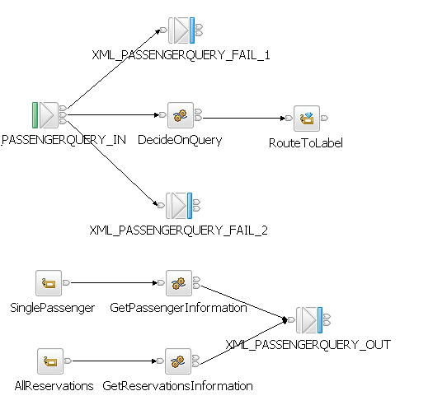

Nodes:

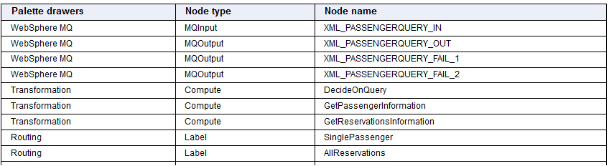

Connecting Nodes:
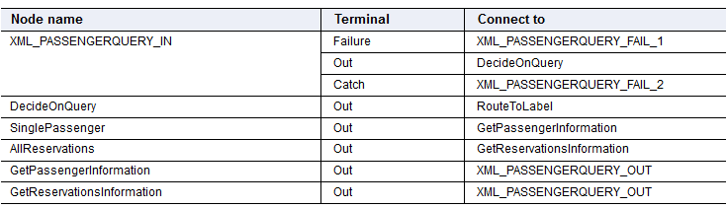

Node Properties:

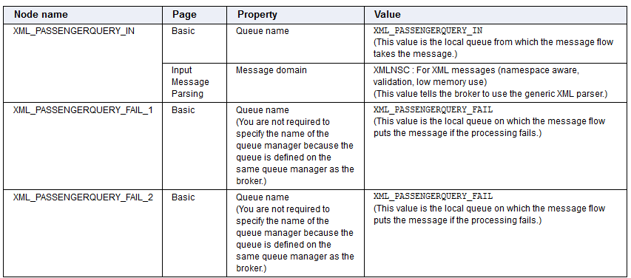
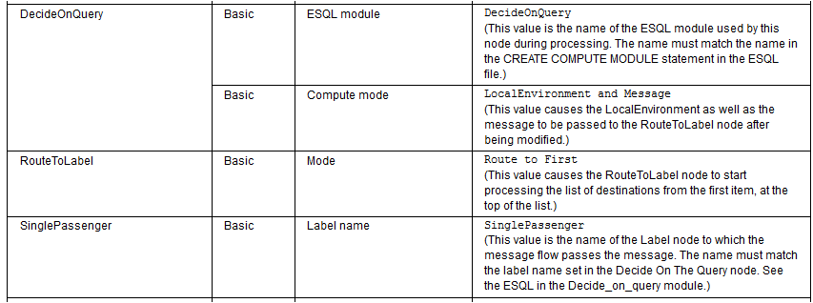

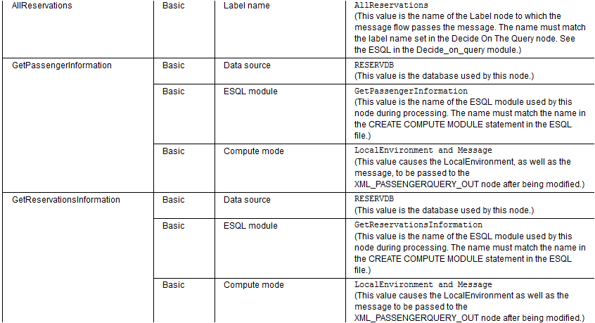

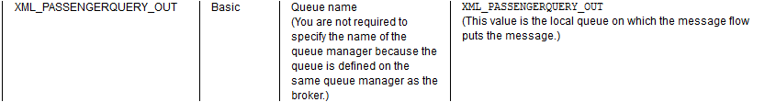

- The XML_PASSENGERQUERY_IN node gets the input message from the XML_PASSENGERQUERY_IN queue and identifies the input message as being in the XMLNSC domain. The message flow must, therefore, parse the message by using the XMLNSC parser.
- The XML_PASSENGERQUERY_IN node passes the message to the DecideOnQuery node. Alternatively:
  - If there is a problem identifying the input message, the node passes the message through the Failure terminal to the XML_PASSENGERQUERY_FAIL_1 node, which puts the message on the XML_PASSENGERQUERY_FAIL queue.
  - If an exception is produced downstream and the message is rolled back, the XML_PASSENGERQUERY_IN node passes the message through the Catch terminal to the XML_PASSENGERQUERY_FAIL_2 node, which puts the message on the XML_PASSENGERQUERY_FAIL queue.
- The DecideOnQuery node decides which path the message takes through the message flow. The path that the message takes depends on the type of information provided in the message. The node updates the local environment with the destination information:
  - If the message contains only a reservation number, the node puts Single Passenger in the local environment, so that the RouteToLabel node passes the first XML_PassengerQuery input message (passengerquery1.mbtest) to the SinglePassenger node.
  - If the message contains a passenger's full name, the node puts All Reservations in the local environment, so that the RouteToLabel node passes the second XML_PassengerQuery input message (passengerquery2.mbtest) to the AllReservations node.
- The DecideOnQuery node passes the message and the local environment through the Out terminal to the RouteToLabel node.
- The RouteToLabel node passes the input message to the relevant Label node: the SinglePassenger node if the DecideOnQuery node put Single Passenger in the local environment; the AllReservations node if the DecideOnQuery node put All Reservations in the local environment.
- If the RouteToLabel node passed the input message to the SinglePassenger node, the SinglePassenger node passes the input message, which contains a reservation number, through the Out terminal to the GetPassengerInformation node. The GetPassengerInformation node looks up the reservation number in the XMLPASSENGERTB table in the RESERVDB database and builds an output message from the information found in the XMLPASSENGERTB table, including the reservation number, the passenger's full name, the flight number, the flight date, and the class of seat. The GetPassengerInformation node then passes the output message through the Out terminal to the XML_PASSENGERQUERY_OUT node.
- If the RouteToLabel node passed the input message to the AllReservations node, the AllReservations node passes the input message, which contains a passenger's name, through the Out terminal to the GetReservationsInformation node. The GetReservationsInformation node looks up the passenger's name in the XMLPASSENGERTB table of the RESERVDB database and builds an output message from the information found in the XMLPASSENGERTB table, including the passenger's full name, and the flight number, flight date, and class of seat for each reservation that the passenger has made. The GetReservationsInformation node then passes the output message through the Out terminal to XML_PASSENGERQUERY_OUT.
- The XML_PASSENGERQUERY_OUT node puts the output message on the XML_PASSENGERQUERY_OUT queue.

Compute Node:
CREATE COMPUTE MODULE DecideOnQuery
CREATE FUNCTION Main() RETURNS BOOLEAN
BEGIN
SET OutputRoot = InputRoot;
IF InputRoot.XMLNSC.PassengerQuery.ReservationNumber <> '' THEN
SET OutputLocalEnvironment.Destination.RouterList.DestinationData[1].labelname = 'SinglePassenger';

ELSE
SET OutputLocalEnvironment.Destination.RouterList.DestinationData[1].labelname = 'AllReservations';
END IF;

RETURN TRUE;
END;
END MODULE;

Compute node:

CREATE COMPUTE MODULE GetPassengerInformation
CREATE FUNCTION Main() RETURNS BOOLEAN
BEGIN
SET OutputRoot = InputRoot;
SET OutputRoot.XMLNSC.PassengerQuery = NULL;
-- populate the environment with passenger info from the database
SET Environment.Variables =
THE (SELECT T.* FROM Database.XMLPASSENGERTB AS T
WHERE T.RESERVATIONNO = InputRoot.XMLNSC.PassengerQuery.ReservationNumber);

-- populate the output message with info from the database query
CREATE FIELD OutputRoot.XMLNSC.PassengerInfoResponse.PassengerInfo;
DECLARE outpass REFERENCE TO OutputRoot.XMLNSC.PassengerInfoResponse.PassengerInfo;
SET outpass.ReservationNumber = Environment.Variables.RESERVATIONNO;
SET outpass.FirstName = Environment.Variables.FIRSTNAME;
SET outpass.LastName = Environment.Variables.LASTNAME;
SET outpass.FlightNumber = Environment.Variables.FLIGHTNO;
SET outpass.Date = Environment.Variables.FLIGHTDATE;
SET outpass.Class = Environment.Variables.CLASSTYPE;
RETURN TRUE;
END;
END MODULE;

Compute Node 3:
CREATE COMPUTE MODULE GetReservationsInformation
CREATE FUNCTION Main() RETURNS BOOLEAN
BEGIN
SET OutputRoot = InputRoot;
SET OutputRoot.XMLNSC.PassengerQuery = NULL;
-- populate the environment with reservations info from the database
SET Environment.Variables.Reservation[] =
(SELECT T.* FROM Database.XMLPASSENGERTB AS T
WHERE T.FIRSTNAME = InputRoot.XMLNSC.PassengerQuery.FirstName
AND
T.LASTNAME = InputRoot.XMLNSC.PassengerQuery.LastName);

-- populate the output message with info from the database query
CREATE FIELD OutputRoot.XMLNSC.PassengerInfoResponse.ListOfReservations;
DECLARE outres REFERENCE TO OutputRoot.XMLNSC.PassengerInfoResponse.ListOfReservations;
DECLARE I INTEGER 1;
DECLARE J INTEGER CARDINALITY(Environment.Variables.*[]);
WHILE I <= J DO
SET outres.Reservation[I].FlightNumber = Environment.Variables.Reservation[I].FLIGHTNO;
SET outres.Reservation[I].Date = Environment.Variables.Reservation[I].FLIGHTDATE;
SET outres.Reservation[I].Class = Environment.Variables.Reservation[I].CLASSTYPE;
SET I = I + 1;
END WHILE;
RETURN TRUE;
END;
END MODULE;

Executed Code:

CREATE COMPUTE MODULE DecideOnQuery
CREATE FUNCTION Main() RETURNS BOOLEAN
BEGIN

SET OutputRoot=InputRoot;

IF InputRoot.XMLNSC.PassengerQuery.ReservationNumber <> '' THEN

SET OutputLocalEnvironment.Destination.RouterList.DestinationData[1].labelname='SinglePassenger';

ELSE

SET OutputLocalEnvironment.Destination.RouterList.DestinationData[1].labelname='AllReservations';

END IF;

RETURN TRUE;
END;

CREATE PROCEDURE CopyMessageHeaders() BEGIN
DECLARE I INTEGER 1;
DECLARE J INTEGER;
SET J = CARDINALITY(InputRoot.*[]);
WHILE I < J DO
SET OutputRoot.*[I] = InputRoot.*[I];
SET I = I + 1;
END WHILE;
END;

CREATE PROCEDURE CopyEntireMessage() BEGIN
SET OutputRoot = InputRoot;
END;
END MODULE;

CREATE COMPUTE MODULE GetPassengerInformation
CREATE FUNCTION Main() RETURNS BOOLEAN
BEGIN

SET OutputRoot = InputRoot;
SET OutputRoot.XMLNSC.PassengerQuery= NULL;

SET Environment.Variables=THE(SELECT T.* FROM Database.UPENDER.XMLPASSENGERTB AS T WHERE T.RESERVATIONNO=InputRoot.XMLNSC.PassengerQuery.ReservationNumber );

CREATE FIELD OutputRoot.XMLNSC.PassengerInfoResponse.PassengerInfo;

DECLARE outpass REFERENCE TO OutputRoot.XMLNSC.PassengerInfoResponse.PassengerInfo;

SET outpass.ReservationNumber = Environment.Variables.RESERVATIONNO;
SET outpass.FirstName = Environment.Variables.FIRSTNAME;
SET outpass.LastName = Environment.Variables.LASTNAME;
SET outpass.FlightNumber = Environment.Variables.FLIGHTNO;
SET outpass.FlightDate = Environment.Variables.FLIGHTDATE;
SET outpass.Class = Environment.Variables.CLASSTYPE;

RETURN TRUE;
END;

CREATE PROCEDURE CopyMessageHeaders() BEGIN
DECLARE I INTEGER 1;
DECLARE J INTEGER;
SET J = CARDINALITY(InputRoot.*[]);
WHILE I < J DO
SET OutputRoot.*[I] = InputRoot.*[I];
SET I = I + 1;
END WHILE;
END;

CREATE PROCEDURE CopyEntireMessage() BEGIN
SET OutputRoot = InputRoot;
END;
END MODULE;

CREATE COMPUTE MODULE GetReservationsInformation
CREATE FUNCTION Main() RETURNS BOOLEAN
BEGIN
SET OutputRoot = InputRoot;
SET OutputRoot.XMLNSC.PassengerQuery=NULL;

SET Environment.Variables.Reservation[] = (SELECT T.* FROM Database.UPENDER.XMLPASSENGERTB AS T WHERE T.FIRSTNAME=InputRoot.XMLNSC.PassengerQuery.FirstName AND T.LASTNAME=InputRoot.XMLNSC.PassengerQuery.LastName );

CREATE FIELD OutputRoot.XMLNSC.PassengerInfoResponse.ListOfReservations;
DECLARE outref REFERENCE TO OutputRoot.XMLNSC.PassengerInfoResponse.ListOfReservations;

DECLARE i INTEGER 1;
DECLARE j INTEGER CARDINALITY(Environment.Variables.*[]);

WHILE i <=j DO

SET outref.Reservation[i].FlightNumber =Environment.Variables.Reservation[i].FLIGHTNO;
SET outref.Reservation[i].FlightDate =Environment.Variables.Reservation[i].FLIGHTDATE;
SET outref.Reservation[i].Class =Environment.Variables.Reservation[i].CLASSTYPE;

SET i=i+1;

END WHILE;

RETURN TRUE;
END;

CREATE PROCEDURE CopyMessageHeaders() BEGIN
DECLARE I INTEGER 1;
DECLARE J INTEGER;
SET J = CARDINALITY(InputRoot.*[]);
WHILE I < J DO
SET OutputRoot.*[I] = InputRoot.*[I];
SET I = I + 1;
END WHILE;
END;

CREATE PROCEDURE CopyEntireMessage() BEGIN
SET OutputRoot = InputRoot;
END;
END MODULE;

